**Recommendation Algorithm:**

**Recommendation algorithms have two types**.

1. Content based recommendation
2. Collaborative filtering
3. **Content based recommendation:**

* Supervised machine learning used to induce a classifier to differentiate between interesting and non interesting items for the user.
* Content based systems recommend the items to customers similarly to previously high rated items by the customer.
* It uses features and properties for the item. These properties can calculate the similar between items.

**Content based recommended algorithm working Steps:**

* First create a profile of the item.
* User profile inferred with for particular user
* We use these profiles to recommend the products from the user catalog

1. **Item profile:**

We need to create a profile for each item with properties: eg. if the movie is an item movie title, genre, duration, actors, director and releasing year.

For the document, important property type of content and set to the importance words on it.

TF-IDF - ( Term Frequency Inverse document frequency )

**Term Frequency (TF)**

TF is defined as number of same words appears in the document. Eg the animal word is appears in document is 5 times. Divided by total number of words 100.

***TF = most word appeared in document (animal) / no of the words in document***

**Inverse Document Frequency (IDF)**

IDF is defined has the its not used more customers very often or rarely used a customer not all customer often using (High IDF).

**IDF = log(*total no of documents (100) / no of documents appeared in animal word (10)*)**

**Term Frequency Inverse Document Frequency (TF- IDF)**

TF-IDF will identify both frequently chosen by a specific customer and not commonly purchased by others.

***TF-IDF = TF x IDF***

1. **User Profile:**

User profile is vector that describes the user preference

During the creation the user profile we have to use the utility matrix that describes the relationship between user and item.

For this much information we can know that user which one is like and dislike profile of the items.

Advantages:

* No need for data on other users when applying to similar user.
* Able to recommend to the user with unique items.
* Able to recommend the popular items and new items.

Disadvantages:

* Finding the appropriate feature is hard.
* Doesn’t recommend the items outside of user profile

**B. Collaborative Filtering:**

* It identifies the pattern in user behavior and preferences, essential for harnessing the idea that people who liked X also liked Y

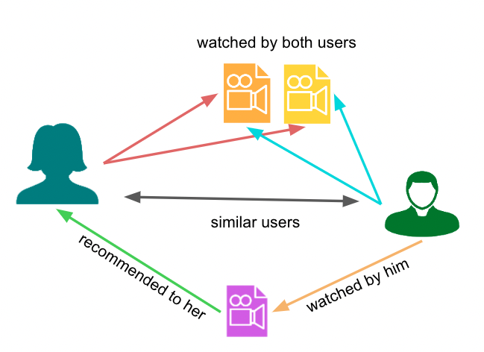

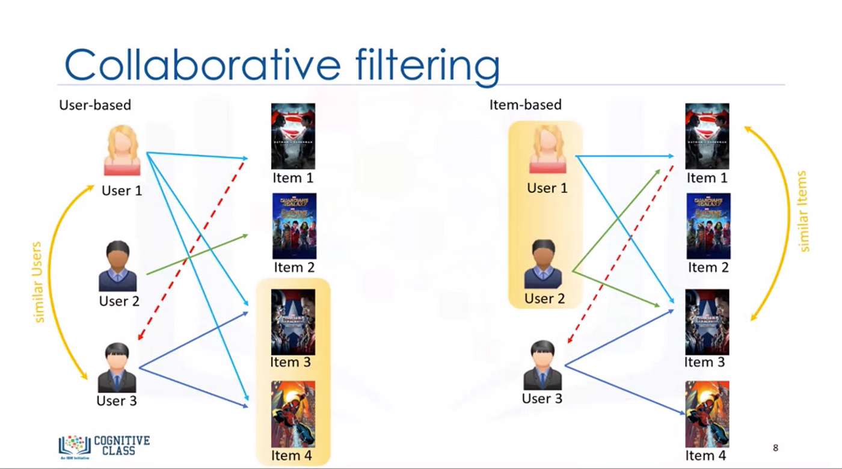

Advantages:

* No need for domain knowledge because the embedding are learned automatically.
* Capture inherent subtle characteristics

Disadvantages:

* Cannot handle the fresh items due to cold start problem
* Hard to add any new features that may improve the quality of the model